README FILE (Quality Control)
Updated: 2018 May 25

For any number of reasons (e.g., sensor failure, tower shadowing) a (hopefully small) proportion of the data points in the data set will be “bad.” These data points do not accurately characterize the physical property that is being measured. The purpose of quality control is to scrub the raw data set of bad measurements to create a processed data set that accurately characterizes the physical properties at the site during the monitoring period. Rigorous QC of the collected data is vital for correctly characterizing the wind resource at the monitoring sites. This accurate characterization of the measured data is important for the follow-on wind resource modeling effort, as the results of the modeling only can be as good as the data used to inform the modeling effort. Lastly, a wind resource model with less uncertainty allows for lower-cost financing of wind projects (due to higher investor/lender confidence) and thus a lower cost of energy.
Data QC is not an exact science. Therefore, good practice calls for both preserving the raw data and documenting the QC process. This allows the QC process to be revisited later, and for use of a different QC process if desired.
The data QC for this project was conducted using the Windographer wind-data analysis software (version 3.310). As part of the QC process, a series of filters were applied to the data to screen out invalid or suspect data points. These data filters include tower shading, consistency checks, and visual inspection. The filtering methodologies are described in more detail below.
Tower Shadow
Data are removed in a 30-degree area centered on the axis of each anemometers boom. These data exhibit wind speed readingslower than the actual wind speeds because the tower is blocking part of the wind that should be acting on the instrument. This is shown in Figure 1, which depicts 80 m wind-speed data from Mongla.
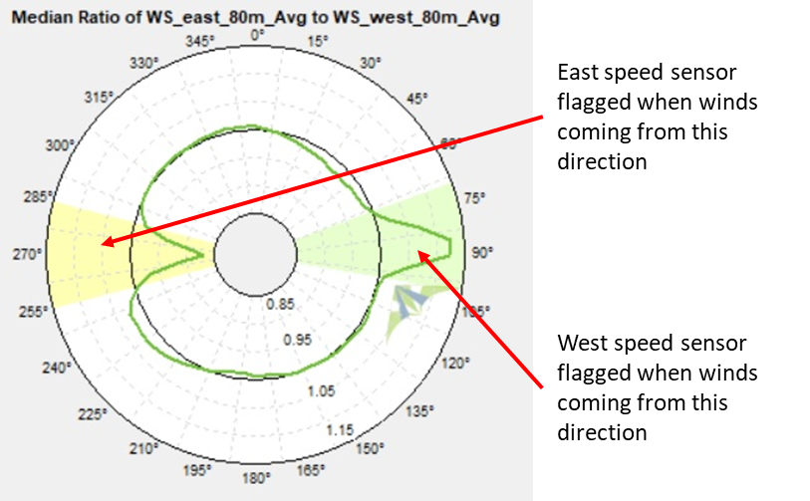
Figure 1. Tower shadow

Consistency Checks (Sensor Pair Comparison)
Whenever possible, it is useful to look at instruments relative to one another. For example, the two wind-speed sensors at each level were compared to ensure that there were no issues with any of the sensors. This filter often identifies problems with sensor configurations and sensor failure. This is shown in Figure 2 which uses the data from the Mymensingh 80 m sensor pair.

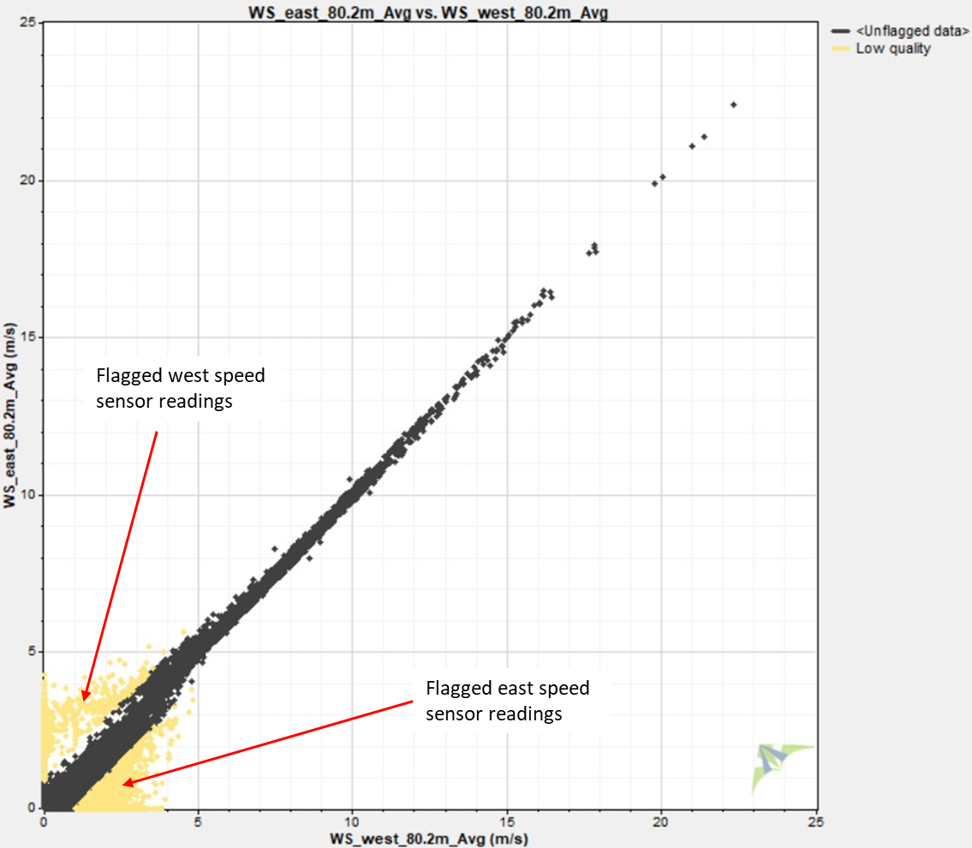
Figure 2. Sensor pair comparison

Instrument Failure
Sometimes instruments drop out for various reasons, and these data points typically are filtered out manually by visual inspection, as shown in Figure 3, which is a time series plot of temperature from Rajshahi.
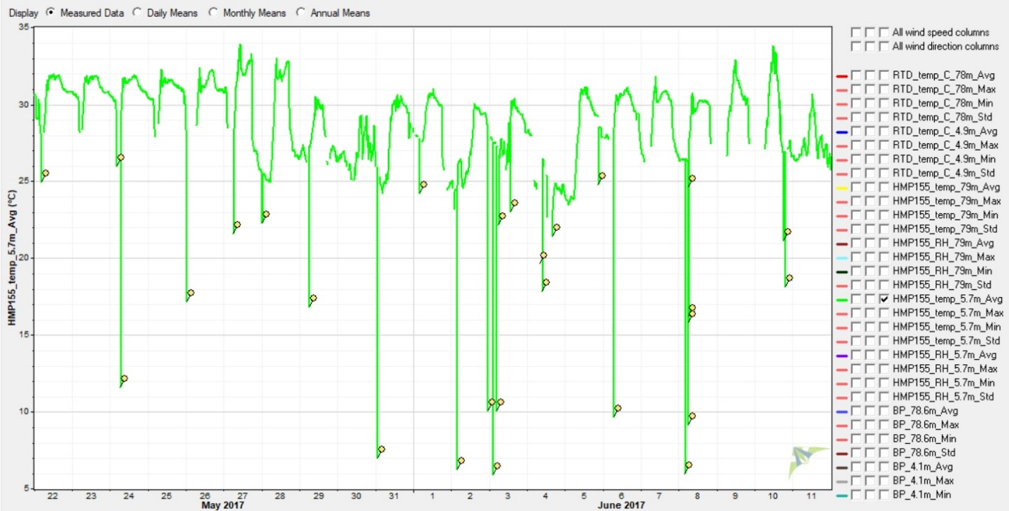
Figure 3. Visual inspection

Corrected Transfer Function
The pressure sensors used at Rajshahi were a different model than those used at the other tower sites and thus an incorrect transfer function was entered into the logger. To correct for this incorrect transfer function, during the QC process a corrective transfer function of y = 0.5x + 300 was applied to the barometric pressure readings for this site.

Miscellaneous
The following miscellaneous screens were applied to the data:
- Quality Factor (QF) (SODAR Only). Data points with a quality factor of less than 90% were excluded.
- Rain (SODAR Only). SODAR units perform poorly when it rains. All wind speed, vertical wind speed, and wind direction data was flagged when the relative humidity exceeded 95%.
- Vertical Wind Speed (SODAR Only). When the vertical wind speed at a given height exceeded 0.5 m/s, the (horizontal) wind speed reading for that height was flagged.

https://www.windographer.com/.

